User Manual
PC-DMIS – Q-DAS Converter Version 2.3.x

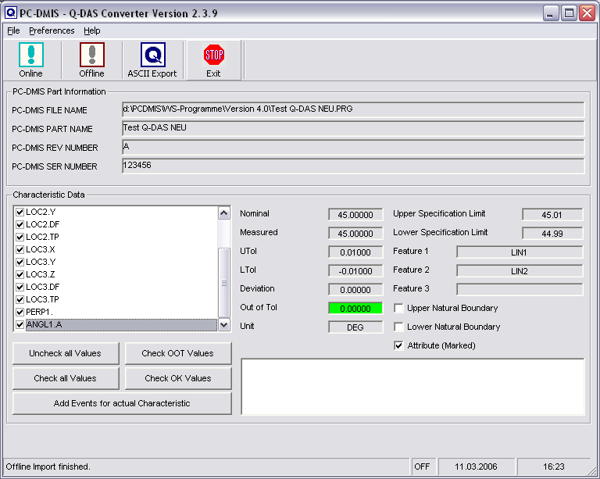
Copyright © 2002-2010 Hexagon Metrology GmbH - Germany
Contents
1. General information 3
1.1. Software objectives 3
1.2. Software requirements 3
1.3. Software warranty and support 3
2. Installation instructions 4
2.1. Shipping contents 4
2.2. Installation 4
2.3. Uninstalling the software 4
3. Using the software 5
3.1. Language setting 5
3.2. Creating the measurement program in PC-DMIS 5
3.3. Launching the PC-DMIS – Q-DAS Converter software 9
3.4. User interface of the PC-DMIS – Q-DAS Converter software 9
3.5. Configuration of the converter 10
3.6. Offline conversion 16
3.7. ONLINE conversion 19
3.8. Execute the converter from the PC-DMIS part program 19
3.9. List of supported Q-DAS K fields 21
3.10. List of supported dimension types in PC-DMIS™ 23

Note: Despite every effort, we are unable to fully preclude the possibility of errors in the documentation. We will be pleased to receive any hints or suggestions you may have.

We would like to express our special thanks to the Q-DAS® company for their excellent cooperation during development of this converter. We would also like to thank all our customers who provided us with very good support with test and information during development.



Q-DAS®
Gesellschaft für Datenverarbeitung und Systemtechnik mbH
Eisleber Strasse 2
D-69469 Weinheim
Germany

General information

Software objectives
This software has been developed to allow generation of qs-STAT® data under the PC-DMIS™ software package, Version 3.5 and higher.
The converter allows manual conversion (OFFLINE) or automatic conversion from the part program (ONLINE).

Software requirements
The software has been developed for the Windows NT 4.0, Windows 2000 and Windows XP operating systems. No software tests have been conducted with other operating systems.

The tests of compatibility of the data generated with qs-STAT® were conducted with version qs-STAT® Millennium. However, in accordance with Q-DAS®, the format may also be used for less recent versions.
PC-DMIS™ Version 3.5 or higher must be installed on the same computer in order to be able to use the software practically.

Software warranty and support
See current license.txt file in the installation folder of the software.

Installation instructions

Shipping contents
The software is available for download on the DEA – Brown & Sharpe GmbH ftp-Server.

ftp://ftp.dea3d.de/DEA-Addon/PC-DMIS-Q-DAS_Converter_Version_2

or
http://ftp.dea3d.de/DEA-Addon/PC-DMIS-Q-DAS_Converter_Version_2

Installation
To install the software execute the setup .exe file. Please follow the commands of the setup routine carefully.

After starting the software, the system will check automatically if a license exist. Otherwise you will see the following dialog which allows you to generate a license request:
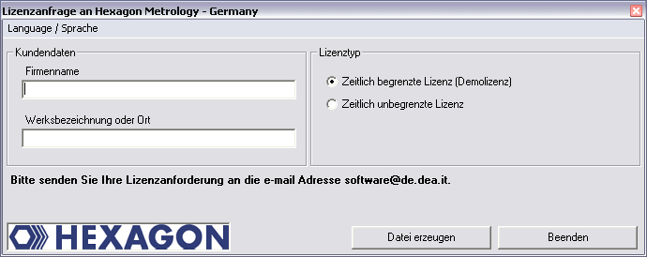
The menu Language / Sprache allows to change between German and English language.

After you receive your license please copy this file (KundenLizenz.dat) in the installation folder of the software. If you like to use a plant or company license you should receive this file from your software supplier.

Uninstalling the software
Should you need to uninstall the software later, you can do this with the uninstall routine in the program folder.

Using the software

Language setting
The Software is available in the following languages:

- English
- German
- French
- Italian
- Czech
- Spanish
- Portuguese
- Hungarian (starting from 2.3.11)

If you need a different language, please contact your software supplier.

The language can be selected using the File – Language menu. With the selection you decide also the axis letters (specially if the converter should be compatible with Version 1).

Creating the measurement program in PC-DMIS
Create your measurement program as normal using the PC-DMIS™ software, Version 3.5 or higher. Note the following during creation of the evaluation:
a) The output option must be set to “STATS” or “BOTH” for evaluations which are to be included in the statistics.
b) Command “STATS/ON” , STATS/OFF and
STATS/TRANSFER ,DIRECTORY={Target directory} will be supported, if the check box “Support of Stat commands” will be activated in the Setup dialog.

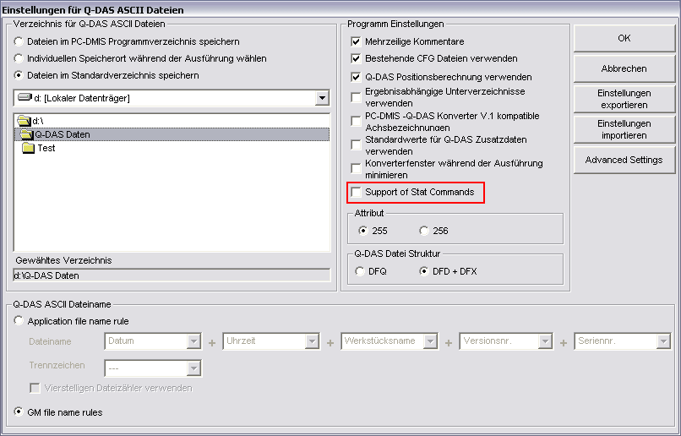

If this check is activated, the converter will not read dimensions or other commands before the STATS/ON command is included in the part program.

The STATS/OFF command will be something like a pause command, you can activate the data transfer to the converter with the STATS/ON command again. All commands between STATS/OFF and STATS/ON will not be read from the converter.

The STATS/TRANSFER command will allows you to define a target directory in the part program. This target directory will override the converter default settings.
The command will also close the Online process. Depending on the start up option (/i or /a) the export of the Q-DAS ASCII file will start automatically (/i) or not (/a).
c) Trace fields are supported for the following K-fields:
Key | /0 | Description | Length | Type | catalog basedt | Customer description | DFD  DFX | Remarks
Values / add. Data
K0006 |  | Batch number | 14 | A |  |  | DFX | "#" must be used
K0007 |  | Cavity number | 5 | I | X |  | DFX
K0008 |  | Operator name | 5 | I | X |  | DFX
K0009 |  | Text | 255 | A |  |  | DFX
K0010 |  | Machine number | 5 | I | X |  | DFX
K0012 |  | Gage number | 5 | I | X |  | DFX
K0053 |  | Order | 20 | A |  |  | DFX
Parts data
K1021 |  | Manufacturer No. | 20 | A |  |  | DFD
K1022 |  | Manufacturer name | 80 | A |  |  | DFD
K1031 |  | Material number | 20 | A |  |  | DFD
K1032 |  | Material description | 40 | A |  |  | DFD
K1041 |  | Drawing number | 30 | A |  |  | DFD
K1042 |  | Drawing Amendment | 20 | A |  |  | DFD
K1052 |  | Contractor Name | 40 | A |  |  | DFD
K1053 |  | Order | 40 | A |  |  | DFD
Characteristics data
K2001 |  | Characteristic number | 20 | A |  |  | DFD
K2005 | X | Characteristics class | 1 | I | Module AS/PC/PV  definierte Feldinhalte |  | DFD
K2006 | X | Controll item | 1 | I | definierte Feldinhalte |  | DFD
K2320 |  | Contract number | 20 | A |  |  | DFD | only for all characteristics
K2401 |  | Gage number | 40 | A |  |  | DFD | only for all characteristics
K2402 |  | Gage description | 80 | A |  |  | DFD | only for all characteristics
Additional Trace fields
FileName |  | String for file name | 255 | A

In PC-DMIS™ one dimension includes sometimes more then one characteristic. Then you can use for K2005 or K2006 more then one value separated by comma. The value is used for the next characteristic in the part program. If you use more then one value (separated by comma) then each value is for the next characteristic. In the following example program you can see this by the different colors.

If you use the Trace commands, you should disable the Keys in the user interface using the Setup for Q-DAS Keys.

DISPLAYPRECISION/3
TRACEFIELD/NO_DISPLAY,LIMIT=1 ; K2005/0 : 3
TRACEFIELD/NO_DISPLAY,LIMIT=1 ; K2006/0 : 1
COMMENT/REPT,LOC1 / X-Axis for Hole 204
,LOC1 / Y-Axis for Hole 204
,LOC1 / Z-Axis for Hole 204
,LOC1 / Diameter for Hole 204
DIM LOC1= LOCATION OF CIRCLE CIR1 UNITS=MM ,$
GRAPH=OFF TEXT=OFF MULT=10.00 OUTPUT=BOTH
AX NOMINAL +TOL -TOL MEAS DEV OUTTOL
X 203.199 0.000 0.000 203.199 0.000 0.000 ----#----
Y 76.200 0.000 0.000 76.200 0.000 0.000 ----#----
Z 0.000 0.000 0.000 0.000 0.000 0.000 ----#----
D 25.400 0.000 0.000 25.400 0.000 0.000 ----#----
END OF DIMENSION LOC1
TRACEFIELD/NO_DISPLAY,LIMIT=15 ; K2005 : 2,2,2,2
TRACEFIELD/NO_DISPLAY,LIMIT=15 ; K2006 : 0,0,1,1
COMMENT/REPT,LOC2 / X-Axis for Hole 204
,LOC2 / Y-Axis for Hole 204
,LOC2 / Diameter for Hole 204
,LOC2 / True Position for Hole 204
DIM LOC2= TRUE POSITION OF CIRCLE CIR1 UNITS=MM ,$
GRAPH=OFF TEXT=OFF MULT=10.00 OUTPUT=BOTH DEV PERPEN CENTERLINE=OFF DISPLAY=DIAMETER
AX NOMINAL +TOL -TOL BONUS MEAS DEV OUTTOL
X 203.199 203.199 0.000
Y 76.200 76.200 0.000
DF 25.400 0.000 0.000 0.000 25.400 0.000 0.000 ----#----
TP MMC 0.000 0.000 0.000 0.000 ----#----
END OF DIMENSION LOC2
DISPLAYPRECISION/4
DIM LOC3= TRUE POSITION OF CIRCLE CIR1 UNITS=MM ,$
GRAPH=OFF TEXT=OFF MULT=10.00 OUTPUT=BOTH DEV PERPEN CENTERLINE=OFF DISPLAY=DIAMETER
AX NOMINAL +TOL -TOL BONUS MEAS DEV OUTTOL
X 203.1990 203.1991 0.0001
Y 76.2000 76.2000 0.0000
DF 25.4000 0.0000 0.0000 0.0000 25.4001 0.0001 0.0001 -------->
TP MMC 0.0000 0.0000 0.0002 0.0002 -------->
END OF DIMENSION LOC3

d) You can insert a report comment in front of each dimension. This comment is then saved in Q-DAS key field K2900. It cannot be changed during the runtime.

Then save your measurement program without quitting the program.

Launching the PC-DMIS – Q-DAS Converter software
You can launch the software by default in program group \ PC-DMIS – Q-DAS Converter.
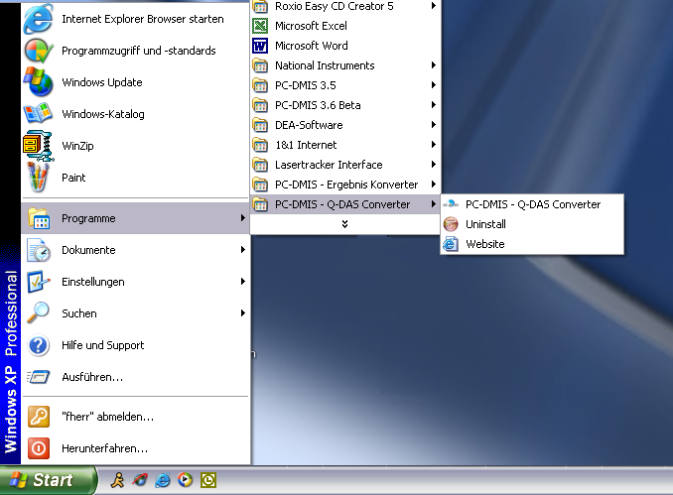

User interface of the PC-DMIS – Q-DAS Converter software
The user interface of the software allows the user to see all his part information’s and results before he will generate the Q-DAS file.

Configuration of the converter
In order to match the converter to the relevant requirements of the application, launch menu item “Setup” in the “Preferences” menu.

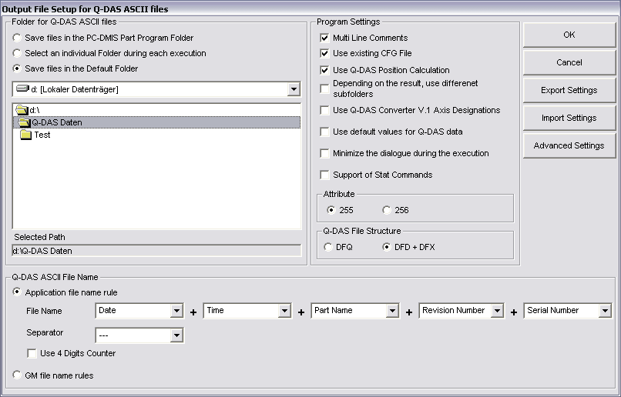

In this dialog, you can choose the directory to which your Q-DAS files are to be saved.

The following options are possible:

- Use PC-DMIS Part Program Folder
If you select this option, the software will save the Q-DAS ASCII files in the same folder as the PC-DMIS part program.
- Select an individual Folder during each execution
During each part program execution, the operator can select a folder, where the software will save the Q-DAS ASCII files.
- Use Default folder
If this option is used, you need to select the default folder in this dialog.

There is also a possibility to use a specific folder name from the command line in the PC-DMIS part program (see chapter 3.8).

In the “Q-DAS ASCII File Name” frame you can configure the file name, which will be used for the Q-DAS ASCII file. Part Name, Revision Number and Serial Number are values which are offered from the PC-DMIS part program header. Date and Time are used from the computer system during the file will be generated. The selected separator will be used between each of the other settings. If you didn’t use the Date and Time setting, you need to use the 4 digits counter, otherwise the software will override the old file.

The GM file name rules will create the following file name format:

{string from Trace field ‘FileName’}_MMDDhhmmss.dfd

or

MMDDhhmmss.dfd

In the “Program Settings” frame are some settings, which allows the operator to configure the software in the best way for his application.

- Multi Line Comments
Comments can be used as additional explanation of the individual characteristics. The respective comment is firmly bound to a characteristic. In order to be able to reach this, some rules in the PC-DMIS Program must be considered.

Whether a comment is used or not, is dependent on the type of the comment and the position in the measuring program.

- The comment must be a protocol comment
- The comment must stand directly before the dimension.
- Comments of several lines are considered up to 20 lines. If more than 20 lines were used, the remaining lines are ignored.

Dependent on the status of the check box you will receive different interpretations of PC-DMIS protocol comments with several lines.

Around this to describe in detail you find in the following two examples:

Example 1:
COMMENT/REPT,Comment for X-Axis
,Comment for Y-Axis
,Comment for Z-Axis
,Comment for D-Axis
MOVE/CLEARPLANE
DIM 1= LOCATION OF CIRCLE KREIS1 UNITS=IN ,$
GRAPH=OFF TEXT=OFF MULT=10.00 OUTPUT=BOTH
AX NOMINAL +TOL -TOL MEAS MAX MIN DEV
X 1.000 0.004 -0.004 1.000 1.441 0.559 0.000 ----#----
Y 1.000 0.004 -0.004 1.000 1.441 0.559 0.000 ----#----
Z 0.000 0.004 -0.004 0.000 -0.079 -0.157 0.000 ----#----
D 1.000 0.008 -0.008 1.000 1.000 1.000 0.000 ----#----
END OF DIMENSION 1

This comment is not used, since MOVE/CLEARPLANE stands a command between the comment and the characteristic.

Example 2:
COMMENT/REPT,Comment for X-Axis
,Comment for Y-Axis
,Comment for Z-Axis
,Comment for the D-Axis
DIM 1= LOCATION OF CIRCLE KREIS1 UNITS=IN ,$
GRAPH=OFF TEXT=OFF MULT=10.00 OUTPUT=BOTH
AX NOMINAL +TOL -TOL MEAS MAX MIN DEV
X 1.000 0.004 -0.004 1.000 1.441 0.559 0.000 ----#----
Y 1.000 0.004 -0.004 1.000 1.441 0.559 0.000 ----#----
Z 0.000 0.004 -0.004 0.000 -0.079 -0.157 0.000 ----#----
D 1.000 0.008 -0.008 1.000 1.000 1.000 0.000 ----#----
END OF DIMENSION 1

The comment is used, since no command between the comment and the characteristic will be placed. Only Trace commands and decimal precision commands can be placed between the comment command and the dimension command.

If Multi Line Comments will be active, you will get the following result:

Dimension | Comment
1.X | Comment for X-Axis
1.Y | Comment for Y-Axis
1.Z | Comment for Z-Axis
1.D | Comment for D-Axis
If Multi Line Comments will be not active, the following interpretation will be used:

Dimension | Comment
1.X | Comment for X-Axis / Comment for Y-Axis / Comment for Z-Axis / Comment for D-Axis
1.Y | Comment for X-Axis / Comment for Y-Axis / Comment for Z-Axis / Comment for D-Axis
1.Z | Comment for X-Axis / Comment for Y-Axis / Comment for Z-Axis / Comment for D-Axis
1.D | Comment for X-Axis / Comment for Y-Axis / Comment for Z-Axis / Comment for D-Axis

- Check for existing CFG File
If this setting is used, the converter check, depending of the name of the part program an the revision number, if a CFG file exists. In this CFG File the operator can save the last settings of the additional Q-DAS data.
- Use Q-DAS Position Calculation
If this check box is marked, the Converter will use K2008, K2030 and K2031 for Position dimensions. If this structure is used, Q-DAS knows, which ordinates are used for which dimension. The calculation of the true position value will be done from qs-STAT®
- Depending on the result, use different subfolders
If this setting is active, the converter will build the following subfolder in the target folder:
a) FirstParts
b) PartOK
c) PartOOT
Results from parts, which are measured the first time, will be saved in the FirstPart folder (independent off the result).
In the PartOK folder the software will save a copy of the Q-DAS ASCII files, if all values are in tolerance. This should be the group of parts, which are delivered.
In the PartOOT folder the converter will save a copy of the Q-DAS ASCII files, if one or more values are out of tolerance.
If you measured a part a second time, you should mark it as a reworked part. The Q-DAS ASCII files will be saved (depending on the result) only in the PartOK or PartOOT folder.
- Use Q-DAS Converter V. 1 Axis Designations
If this option is checked the Converter will use compatible values for K2001 against the Version 1.x.x
- Use default values for Q-DAS data
If this option is checked, the converter offers the same settings for the add. Q-DAS data for all part programs. The defaults have to be saved one time in the dialog.
- Minimize the dialogue during execution
This setting allows the operator to decide, if the dialogue will be minimized during the execution.
- Attribute
If a dimension is not marked in the PC-DMIS part program, the converter will set the Attribute (K0002) to 255 or 256. The meaning of this values you can find in your Q-DAS documentation. If the dimension command is marked, the converter will use the value 0.
- Q-DAS File structure
The converter can create Q-DAS ASCII files in the following formats:
a) DFQ
b) DFD and DFX
IMPORTANT: If you like to use Q-DAS Monitoring software, you must use DFD and DFX.
OK Store the values in the registry of your computer (HKEY_LOCAL_MACHINE \ SOFTWARE \ DEAGERMANY \ PCDQDAS \ Settings) and close the dialog.
Cancel Cancel will close the dialog without saving the values.
Export Settings This button will save the settings in an external file (OutputFile_Settings.cfg) in the installation folder of the software. This file can be used for the configuration of a second systems or if you need to work with different settings.
Import Settings This button will import the OutputFile_Settings.cfg file.

Advanced Settings This button will open a dialog for special settings to fit the converter with your qs-STAT package.

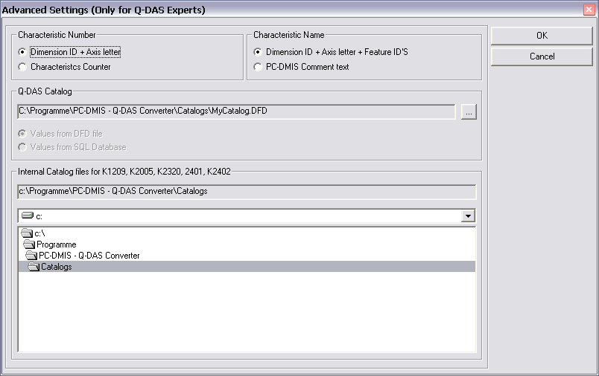

Please contact your statistical expert before changing this parameters.

Output file settings for Q-DAS Monitoring
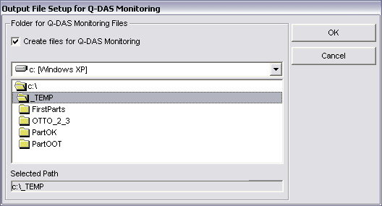
In this dialog you can define a folder, where the converter will store the files for the Q-DAS Monitoring software. Inside of the selected folder the converter will create an individual subfolder for each part program. For each part program the converter will save one DFD file (00000001.dfd) and for each execution a DFX file (00000001.dfx … 00009999.dfx). The converter will use the first free number for the DFX file.

Q-DAS Settings
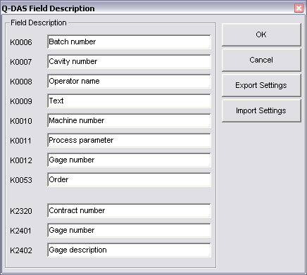
Depending on the customers application Q-DAS often use some K-Fields with a different description as the standard. In this dialog you can fit the converter interface with the used descriptions in qs-STAT®.

The button Export Settings will save the values in the file QDAS_Settings.cfg in the installation folder of the converter software. The OK button will save the values in the registry of your computer.

Setup für Q-DAS Keys
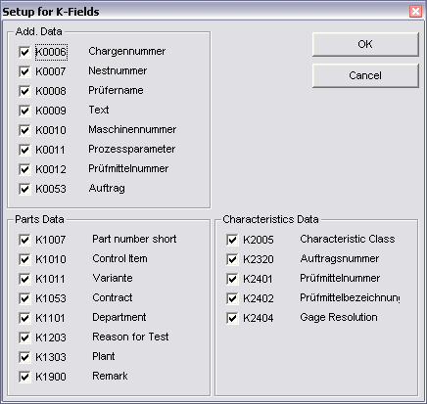
In this dialog you can configure, which K-Fields should be used by the operator. If the check is active, the K-Field is enabled in the operator interface, otherwise the Field is disabled.

You must disable all K-Fields for which you like to use TRACE commands in your part program.

The OK button will save the values in the registry of your computer.

Offline conversion
Launch the converter, as described in Point 3.3, after the measurement program has run.

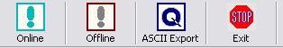

In order to start the conversion operation, click on the <OFFLINE> button. After the converter has received all values from the part program, the following dialog will be opened:
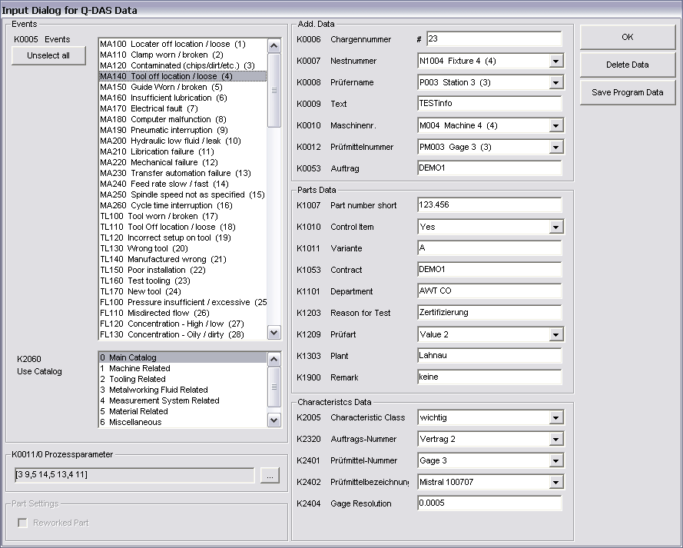

In this dialog you can set your additional Q-DAS data. All values, which you set here, will be used for all characteristics.

Also you can mark your part as an reworked part in this dialog. This setting is only important if you like to use the setting “Depending on the result, use different subfolders”. Otherwise you can ignore this setting.

Tipp:
The process parameter will be configured in a separate dialog. The dialog will be opened by clicking on the ... button.
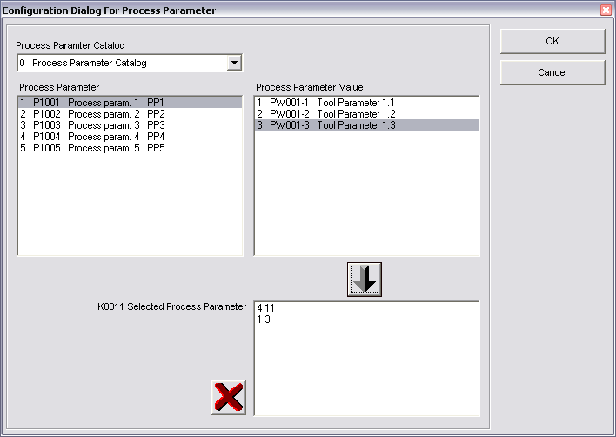
First you select the catalog. Second you select the process parameter. Then you can see all available Values in the value list. After selecting the value you can add the selection with the  button in the list for the selected process parameter. Then you can select the next combination of process parameter and value. With the  button you can delete the complete parameter selection or the marked value in the list.

The Save Data button will save the used settings specially for the actual part program. The system can provide the same settings during the next conversion.

IMPORTAND: You must copy your Q-DAS catalog in the folder catalogs inside of the installation folder of the software. The name of the file must be MyCatalog.dfd
Since Version 2.1.2. there is a registry setting (CatalogPathName) which can be used to define the path and name for the Q-DAS catalog.
In the same folder you can save the possible values for K2320, K2401 and K2402. The name of this files are K2320.dat, K2401.dat and K2402.dat. This files can be edit with a standard editor on your computer.
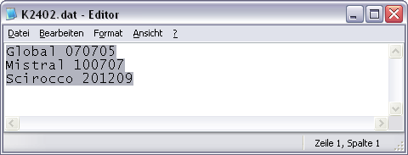

Additional Q-DAS Data for a specific characteristics

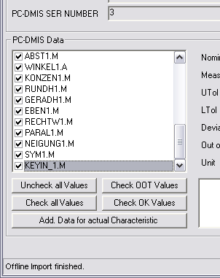

In the PC-DMIS Data frame all imported values are now displayed. The actual displayed value can be selected in the list box. After the import process all check boxes in this list are active. This should be also if you export the values later in the Q-DAS ASCII format.

Before you export the Data in the Q-DAS ASCII format, you can figure out, which values are inside of the tolerance and which not. For this you can use the buttons Uncheck all Values , Check OOT Values , Check all Values and
Check OK Values. With the button Add. Data for actual Characteristic you can add Events for the actual characteristic. Also you can decide, if this characteristic is a control item (K2006). The used catalog is only a filter for the list. If you add an event to an individual characteristic, this characteristic will be set to the main catalog in the Q-DAS ASCII file.

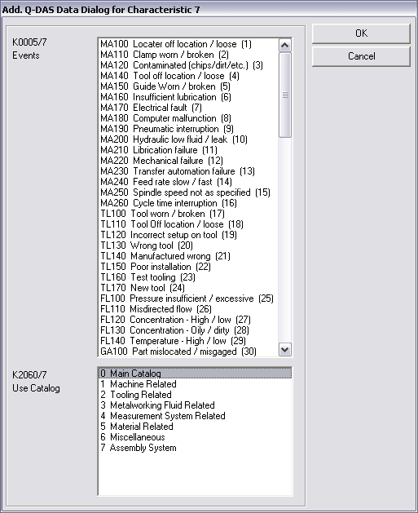

Before you finally export the Q-DAS data, you have to use the Check all Values button. Since Version 2.1.2. this will be done automatically.

Now you can export the Q-DAS ASCII data with the ASCII Export button.

ONLINE conversion

If you like to use the Online functionality of the converter, you need to start the converter before you execute the part program but after you have opened the part program.

The Input dialog for Q-DAS data can be closed during runtime of your part program.

During runtime of the part program the converter receive the Values from PC-DMIS.

This process save a lot off time, which is needed, if you receive the values Offline.

Execute the converter from the PC-DMIS part program
In order to perform the conversion ONLINE, add an external command in the top of your part program.

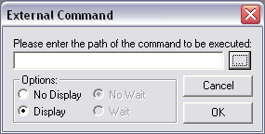
PC-DMIS™ dialogs for external commands

The complete command is as follows:
EXTERNALCOMMAND/NO_DISPLAY, NO_WAIT ; C:\PROGRAMME\PC-DMIS - Q-DAS CONVERTER\PCDQDAS.EXE /A

Parameter “/A“ causes conversion to be launched automatically.

Parameter “/I” can be used on Inline systems, where no operator input should be possible.

Using option “No Display” and “No Wait” to configure the system in the best way.

If you insert this command at the end of the part program (without the parameter “/A” or “/I”) you can pop up the converter without starting the import functionality. Then the operator can use the Offline functionality.

A second parameter can be set. This overwrites the adjusted goal listing for the Q-DAS® ASCII files.

Example:

You like to send the data from this part program to the C:\QDAS_DATA folder.

The complete command is as follows:

EXTERNALCOMMAND/NO_DISPLAY, NO_WAIT ; C:\PROGRAMME\PC-DMIS - Q-DAS CONVERTER\PCDQDAS.EXE /A /C:\QDAS_DATA

Always use for the separation of the command line arguments one "/". Do not use blanks in the path designation.

List of supported Q-DAS K fields
Key | Field
K0001 | Measured value
K0002 | Attribute
K0004 | Time
K0005 | Event
K0006 | Batch number
K0007 | Cavity number
K0008 | Operator name
K0009 | Text
K0010 | Machine number
K0011 | Process parameter
K0012 | Gage number
K0053 | Order
K0100 | Total no. of characteristics in file
K1001 | Part number
K1002 | Part description
K1004 | Part amendment status
K1007 | Abbreviation part number
K1010 | Control item
K1011 | Variant
K1021 | Manufacturer No.
K1022 | Manufacturer name
K1031 | Material number
K1032 | Material description
K1041 | Drawing number
K1042 | Drawing Amendment
K1052 | Contractor Name
K1053 | Contract
K1101 | Department
K1203 | Reason for test
K1209 | Inspection type
K1303 | Plant
K1900 | Remark (automatically used)
K2001 | Characteristic number
K2002 | Characteristic description
K2005 | Characteristics class
K2006 | Control item
K2008 | Characteristics group type
K2022 | Decimal places
K2030 | Group number
K2031 | Group element number
K2060 | Events catalog
K2061 | Process parameter catalog
K2101 | Nominal value
K2110 | Lower specification limit
K2111 | Upper specification limit
K2112 | Lower allowance
K2113 | Upper allowance
K2120 | Lower natural boundary
K2121 | Upper natural boundary

Key | Field
K2142 | Unit
K2320 | Contract number
K2401 | Gage number
K2402 | Gage description
K2404 | Gage Resolution
K2900 | Remark

Total number of K fields: 55

List of supported dimension types in PC-DMIS™

DIMENSION_A_LOCATION
DIMENSION_D_LOCATION
DIMENSION_FLATNESS_LOCATION
DIMENSION_H_LOCATION
DIMENSION_L_LOCATION
DIMENSION_PA_LOCATION
DIMENSION_PD_LOCATION
DIMENSION_PR_LOCATION
DIMENSION_R_LOCATION
DIMENSION_ROUNDNESS_LOCATION
DIMENSION_RS_LOCATION
DIMENSION_RT_LOCATION
DIMENSION_S_LOCATION
DIMENSION_STRAIGHTNESS_LOCATION
DIMENSION_T_LOCATION
DIMENSION_X_LOCATION
DIMENSION_Y_LOCATION
DIMENSION_Z_LOCATION

DIMENSION_TRUE_DIAM_LOCATION
DIMENSION_TRUE_D1_LOCATION
DIMENSION_TRUE_D2_LOCATION
DIMENSION_TRUE_D3_LOCATION
DIMENSION_TRUE_DD_LOCATION
DIMENSION_TRUE_DF_LOCATION
DIMENSION_TRUE_FLATNESS_LOCATION
DIMENSION_TRUE_LD_LOCATION
DIMENSION_TRUE_LF_LOCATION
DIMENSION_TRUE_PA_LOCATION
DIMENSION_TRUE_PR_LOCATION
DIMENSION_TRUE_ROUNDNESS_LOCATION
DIMENSION_TRUE_STRAIGHTNESS_LOCATION
DIMENSION_TRUE_WD_LOCATION
DIMENSION_TRUE_WF_LOCATION
DIMENSION_TRUE_X_LOCATION
DIMENSION_TRUE_Y_LOCATION
DIMENSION_TRUE_Z_LOCATION

DIMENSION_2D_ANGLE
DIMENSION_2D_DISTANCE
DIMENSION_3D_ANGLE
DIMENSION_3D_DISTANCE
DIMENSION_ANGULARITY
DIMENSION_COAXIALITY
DIMENSION_CONCENTRICITY
DIMENSION_FLATNESS
DIMENSION_KEYIN
DIMENSION_PARALLELISM
DIMENSION_PERPENDICULARITY
DIMENSION_PROFILE
DIMENSION_ROUNDNESS
DIMENSION_RUNOUT
DIMENSION_STRAIGHTNESS
DIMENSION_SYMMETRY

